**Task 1**

|  |  |
| --- | --- |
| Test Case | Create order by Manager |
| Objective | To ensure the user Manager can create a new order |
| Pre-Condition | 1. The system is installed and accessible. 2. Users Manager have valid accounts with appropriate permissions. |
| Test Step | 1. Login using user Manager 2. Click on the “Create” button to create a new order 3. Input with valid data 4. Click on the “Submit” button |
| Expected Result | 1. New order has been created |

|  |  |
| --- | --- |
| Test Case | Edit order by Manager |
| Objective | To ensure the user Manager can update the order |
| Pre-Condition | 1. The system is installed and accessible. 2. Users Manager have valid accounts with appropriate permissions. |
| Test Step | 1. Login using user Manager 2. Select one of the order data available 3. Edit the editable data 4. Click on the “Update” button |
| Expected Result | 1. The order data is successfully updated |

|  |  |
| --- | --- |
| Test Case | Delete order by Manager |
| Objective | To ensure the user Manager can delete the order |
| Pre-Condition | 1. The system is installed and accessible. 2. Users Manager have valid accounts with appropriate permissions. |
| Test Step | 1. Login using user Manager 2. Select one of the order data available 3. Click on the “Delete” button 4. Click the “Yes” button to confirm the action |
| Expected Result | 1. The order data successfully deleted |

|  |  |
| --- | --- |
| Test Case | Update status order by Chef – On Progress |
| Objective | To ensure the user Chef can update the status become On Progress |
| Pre-Condition | 1. The system is installed and accessible. 2. Users Chef have valid accounts with appropriate permissions. |
| Test Step | 1. Login using user Chef 2. Select one of the order data available 3. Click on the “Receive Order” button 4. Click the “Yes” button to confirm the action 5. Verify the status |
| Expected Result | 1. Order status become “On Progress” |

|  |  |
| --- | --- |
| Test Case | Update status order by Chef – Delivery Ready |
| Objective | To ensure the user Chef can update the status become Delivery Ready |
| Pre-Condition | 1. The system is installed and accessible. 2. Users Chef have valid accounts with appropriate permissions. |
| Test Step | 1. Login using user Chef 2. Select one of the order data available 3. Click on the “Finish Order” button 4. Click the “Yes” button to confirm the action 5. Verify the status |
| Expected Result | 1. Order status become “Delivery Ready” |

|  |  |
| --- | --- |
| Test Case | Receive Notification for Ready Order |
| Objective | To verify that the driver receives a notification when an order is ready for pickup. |
| Pre-Condition | 1. The system is installed and accessible. 2. Users Driver have valid accounts with appropriate permissions. 3. An order is prepared and marked as "Delivery Ready." |
| Test Step | 1. Login using user Driver 2. Click on the notification icon 3. Click one of the notification data |
| Expected Result | 1. The driver receives a notification for a ready order 2. Order details, including items and delivery address, are displayed. |

|  |  |
| --- | --- |
| Test Case | Pickup Order |
| Objective | To verify that the driver can successfully pick up an order after receiving the notification |
| Pre-Condition | 1. The system is installed and accessible. 2. Users Driver have valid accounts with appropriate permissions. 3. An order is prepared and marked as "Delivery Ready." |
| Test Step | 1. Login using user Driver 2. Select one of the order data available 3. Click on the “Pickup” button 4. Click the “Yes” button to confirm the action |
| Expected Result | 1. The system confirms successful order pickup |

|  |  |
| --- | --- |
| Test Case | Deliver Order |
| Objective | To verify that the driver can successfully deliver the order to the customer |
| Pre-Condition | 1. The system is installed and accessible. 2. Users Driver have valid accounts with appropriate permissions. 3. The driver has successfully picked up the order |
| Test Step | 1. Login using user Driver 2. Select one of the order data with “Pickup” status 3. Verify the navigation to the delivery location 4. Click on the “Done” button 5. Click the “Yes” button to confirm the action |
| Expected Result | 1. The system confirms successful order delivery |

Possible flow issue:

1. **Delayed Order Assignment**

Issue: The Manager, responsible for assigning new orders to kitchens in different cities, experiences delays or system issues in assigning orders.

Impact: This delay can lead to late order preparation, affecting the overall delivery timeline.

1. **Missing Order Notification**

Issue: The Driver does not receive a timely notification once an order is marked as "Delivery Ready."

Impact: The Driver may not be aware of the order readiness, leading to delayed pickups and potential customer dissatisfaction.

1. **Notification Overload**

Issue: The Driver receives excessive or redundant notifications, causing confusion

Impact: Excessive notifications may lead to oversight or frustration, potentially affecting the Driver's performance

1. **Incorrect Route Information**

Issue: The Driver receives inaccurate or outdated route information for delivering an order to the customer.

Impact: This may result in delays and disruptions in the delivery process, affecting the overall efficiency of the service.

1. **System Performance Issues**

Issue: The overall system experiences performance issues, such as slow response times or intermittent outages.

Impact: This can hinder the seamless flow of tasks for all users, affecting the project timeline and user experience.

**Task 2**

Possible issues:

1. Login method that only use Web Access code instead of username and password will have the security issues.
2. The elements keep changing their position, which will cause difficulties in the development process because there is no definite format for setting the position of the elements.

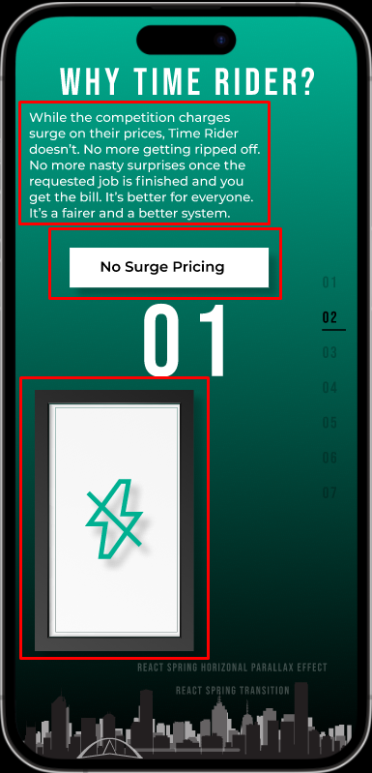 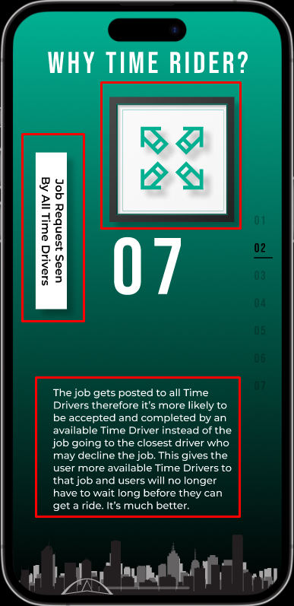

1. Responsiveness of the application.

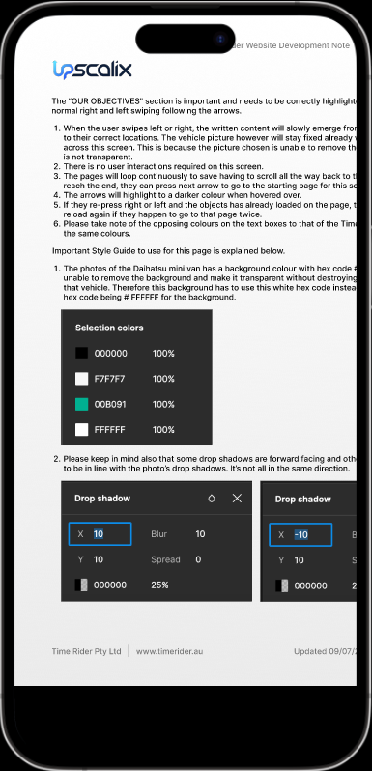

1. The messy position of elements and the use of inappropriate backgrounds make it difficult to read.

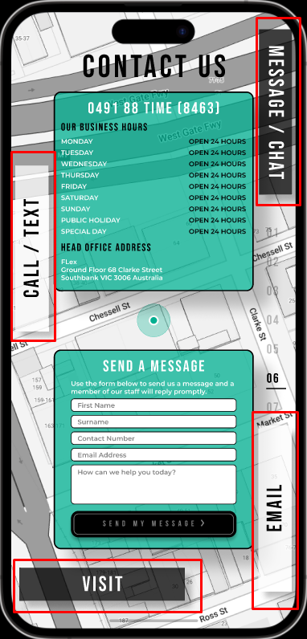

1. Unclear content structure will make it difficult for users to navigate.

